Trial 3 Multispectral Treatment and Growth Comparison Report
This report summarises the Trial 3 relative NDVI and NDRE treatment-comparison workflow. Script 08 used the cell-level multispectral results from Script 07 to calculate tray-level growth rates, treatment-group comparisons, environmental comparisons, and observed-versus-adjusted Day 7 results.
The vegetation indices should be described as relative image-derived NDVI and NDRE unless calibrated reflectance data are available. The analysis is descriptive and should not be interpreted as a formal statistical significance test.

1. Data processed
The analysis contained 5880 cell-day rows, 84 tray-day rows and 12 unique trays.
The observation period was Day 1 on 29 June 2026 through Day 7 on 7 July 2026. Because images were not taken on 5 and 6 July, Day 7 occurred eight elapsed days after the Day 1 image.

2. Day 7 observed and adjusted values
A total of 198 Day 7 cell records were given separate adjusted NDVI/NDRE estimates. Bug-eaten-cell flags were obtained from: Script 05 possible_day7_bug_eaten_cells.csv.
Observed Day 7 values were preserved without alteration. For a flagged cell, the adjusted value was estimated from the latest valid prior multispectral trend. Where at least two earlier valid observations were available, a linear trend was projected to Day 7. Otherwise, the latest valid value was carried forward. All estimated values were limited to the valid index range from -1 to 1.
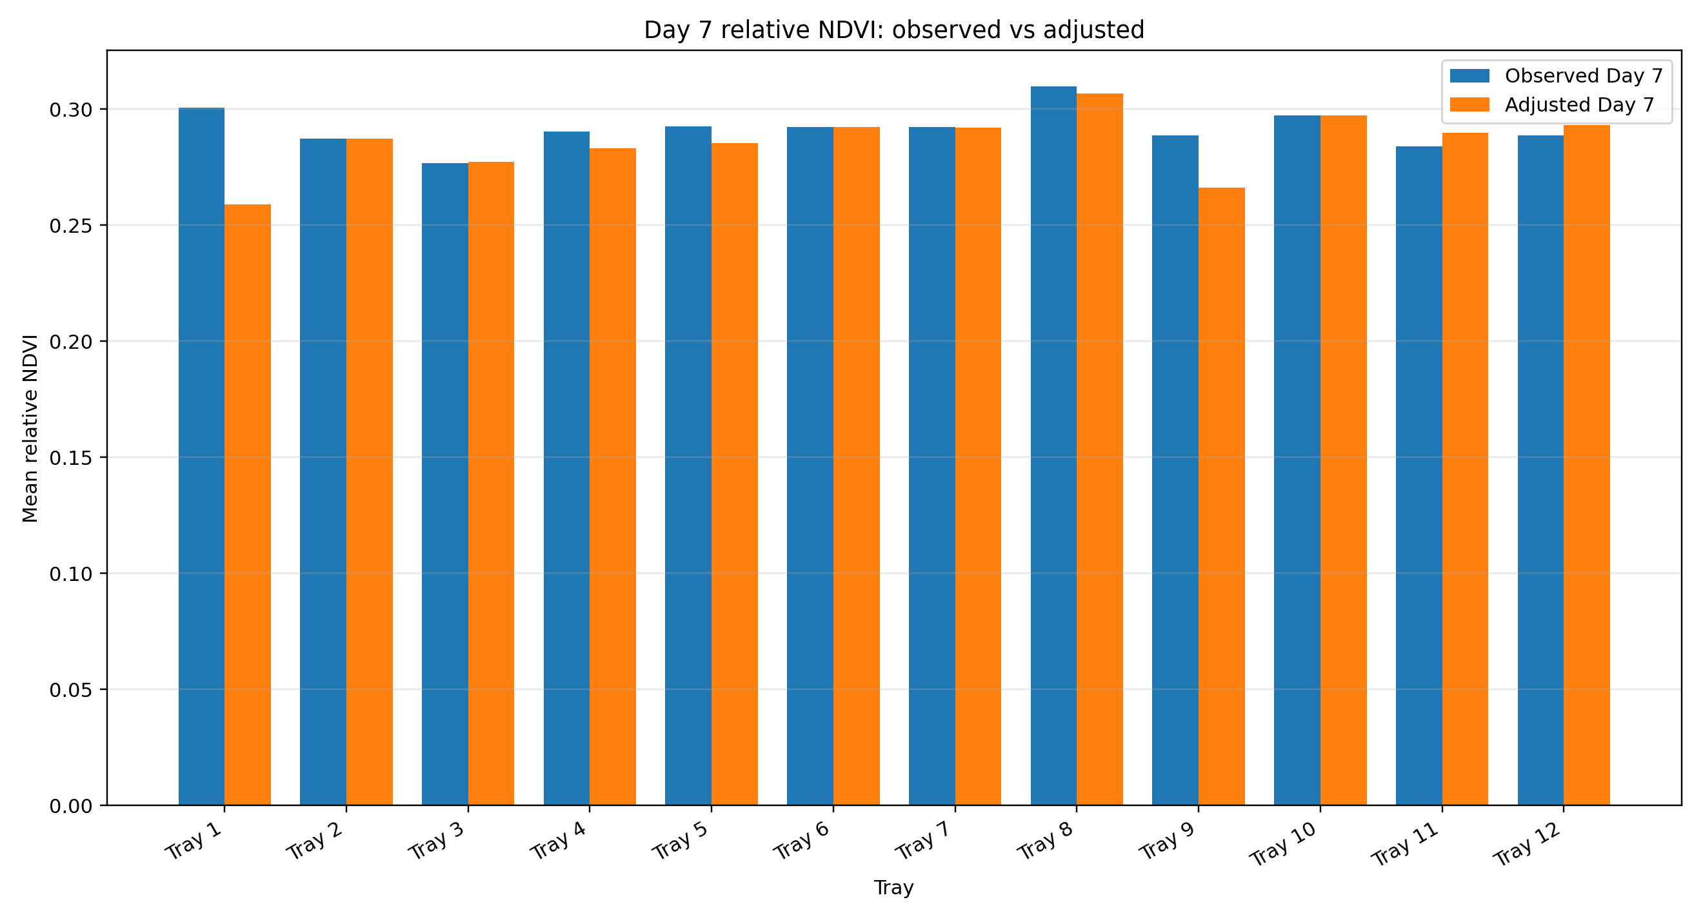
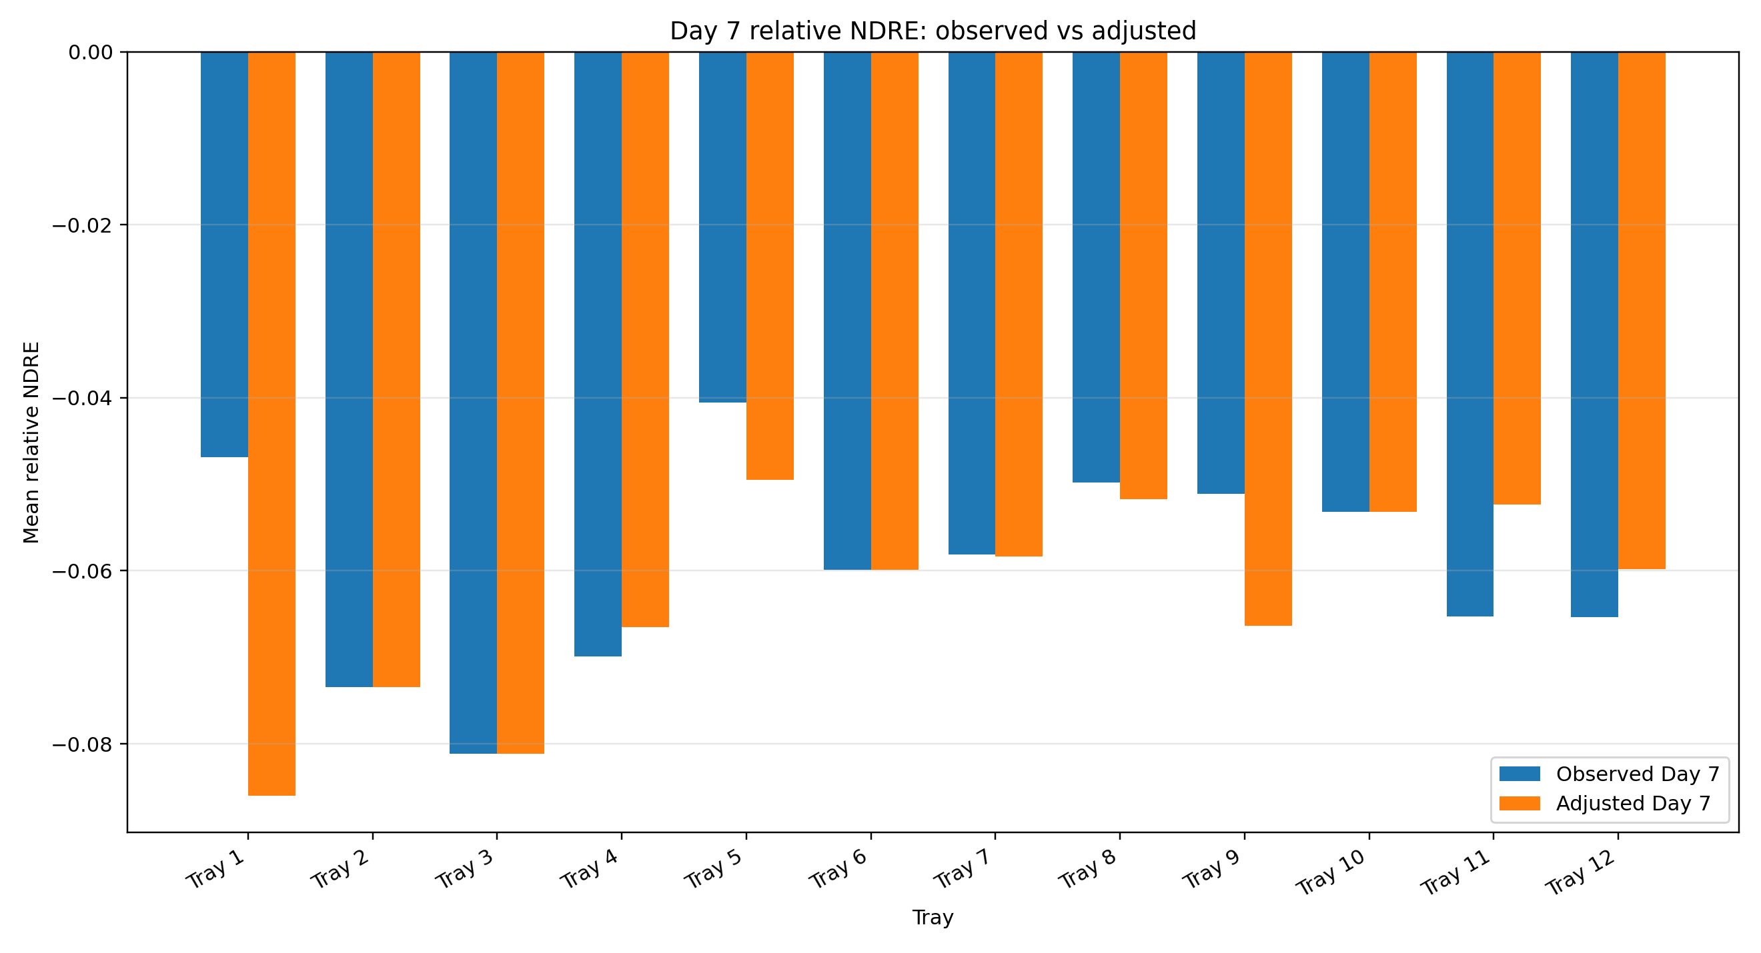
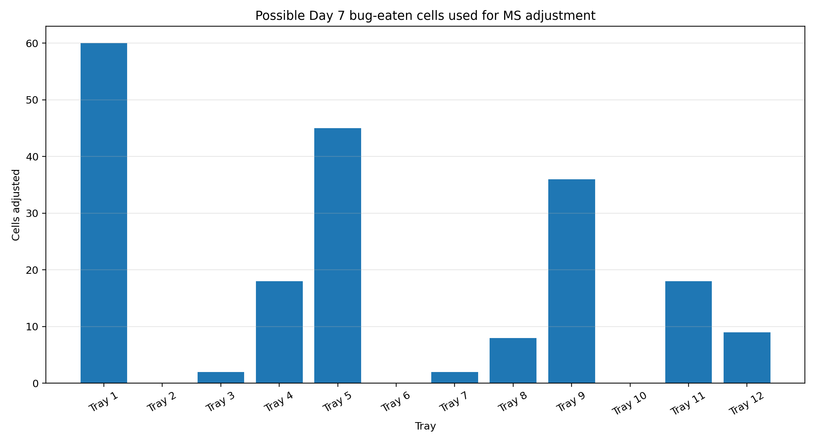

3. Tray-level multispectral results
The highest descriptive adjusted multispectral score was recorded by Tray 8 (Microbes | Heat | Dynamic Heat). Its score was 86.87.
Tray | Microbe Status | Treatment | Environment Group | Day7 Adjusted Ndvi | Day7 Adjusted Ndre | Day7 Imputed Cells | Overall Adjusted Ms Score | Overall Adjusted Ms Rank
Tray 8 | Microbes | Heat | Dynamic Heat | 0.307 | -0.052 | 8 | 86.872 | 1
Tray 10 | Microbes | Moisture | Outside | 0.297 | -0.053 | 0 | 76.539 | 2
Tray 7 | Microbes | Ideal | Outside | 0.292 | -0.058 | 2 | 74.532 | 3
Tray 6 | Microbes | Heat | Dynamic Heat | 0.292 | -0.06 | 0 | 70.399 | 4
Tray 11 | No Microbes | Heat | Dynamic Heat | 0.29 | -0.052 | 18 | 65.94 | 5
Tray 5 | Microbes | Moisture | Inside | 0.285 | -0.05 | 45 | 64.173 | 6
Tray 12 | No Microbes | Moisture | Inside | 0.293 | -0.06 | 9 | 57.225 | 7
Tray 4 | No Microbes | Heat | Dynamic Heat | 0.283 | -0.067 | 18 | 50.128 | 8
Tray 2 | No Microbes | Ideal | Outside | 0.287 | -0.073 | 0 | 46.434 | 9
Tray 9 | Microbes | Ideal | Inside | 0.266 | -0.066 | 36 | 37.735 | 10
Tray 3 | No Microbes | Moisture | Outside | 0.277 | -0.081 | 2 | 35.222 | 11
Tray 1 | No Microbes | Ideal | Inside | 0.259 | -0.086 | 60 | 16.012 | 12
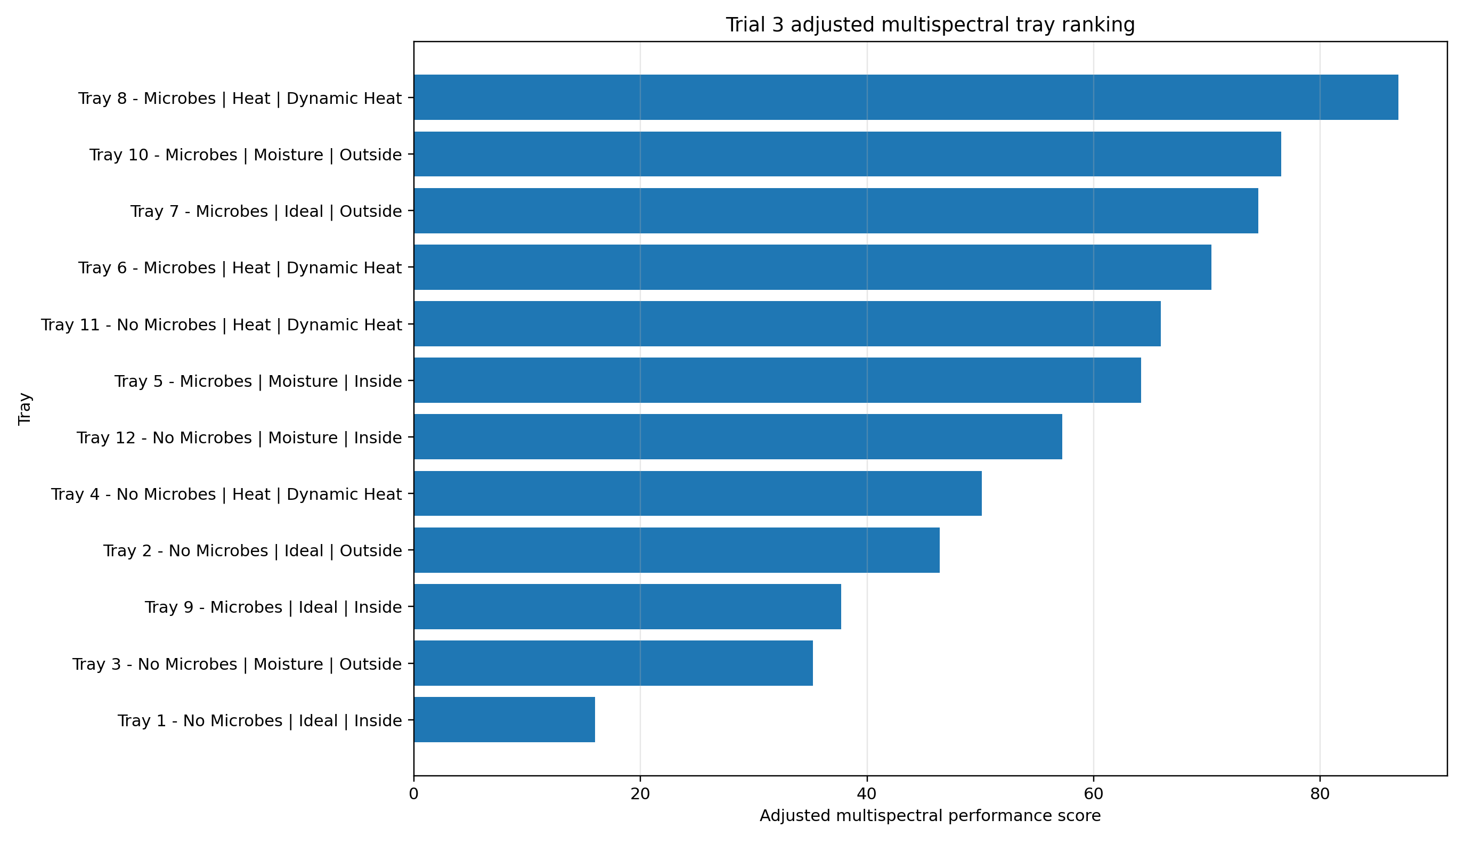

4. Microbes vs No Microbes
The highest mean adjusted Day 7 NDVI in the microbe status comparison was recorded by Microbes (0.290).
The highest mean adjusted Day 7 NDRE in the microbe status comparison was recorded by Microbes (-0.057).
Group | Tray Count | Mean Day7 Adjusted Ndvi | Mean Day7 Adjusted Ndre | Mean Adjusted Ndvi Rate Day1 To Day7 Per Day | Mean Adjusted Ndre Rate Day1 To Day7 Per Day | Mean Overall Adjusted Ms Score
Microbes | 6 | 0.29 | -0.057 | -0.005 | -0.005 | 68.375
No Microbes | 6 | 0.282 | -0.07 | -0.004 | -0.002 | 45.16
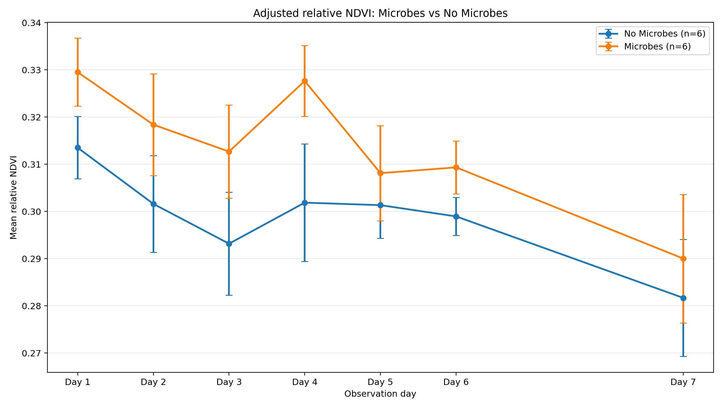
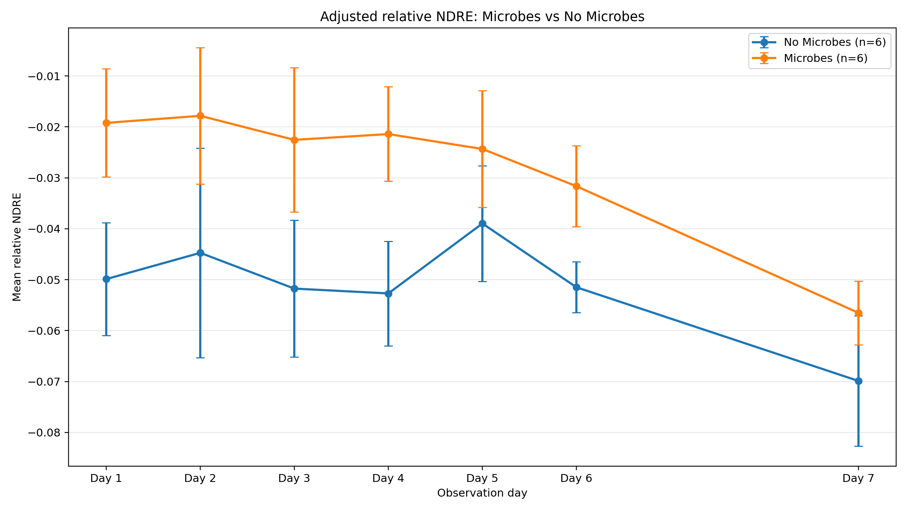

5. Ideal vs Heat vs Moisture
The highest mean adjusted Day 7 NDVI in the treatment type comparison was recorded by Heat (0.293).
The highest mean adjusted Day 7 NDRE in the treatment type comparison was recorded by Heat (-0.058).
Group | Tray Count | Mean Day7 Adjusted Ndvi | Mean Day7 Adjusted Ndre | Mean Adjusted Ndvi Rate Day1 To Day7 Per Day | Mean Adjusted Ndre Rate Day1 To Day7 Per Day | Mean Overall Adjusted Ms Score
Heat | 4 | 0.293 | -0.058 | -0.003 | -0.002 | 68.335
Ideal | 4 | 0.276 | -0.071 | -0.006 | -0.006 | 43.678
Moisture | 4 | 0.288 | -0.061 | -0.004 | -0.003 | 58.29
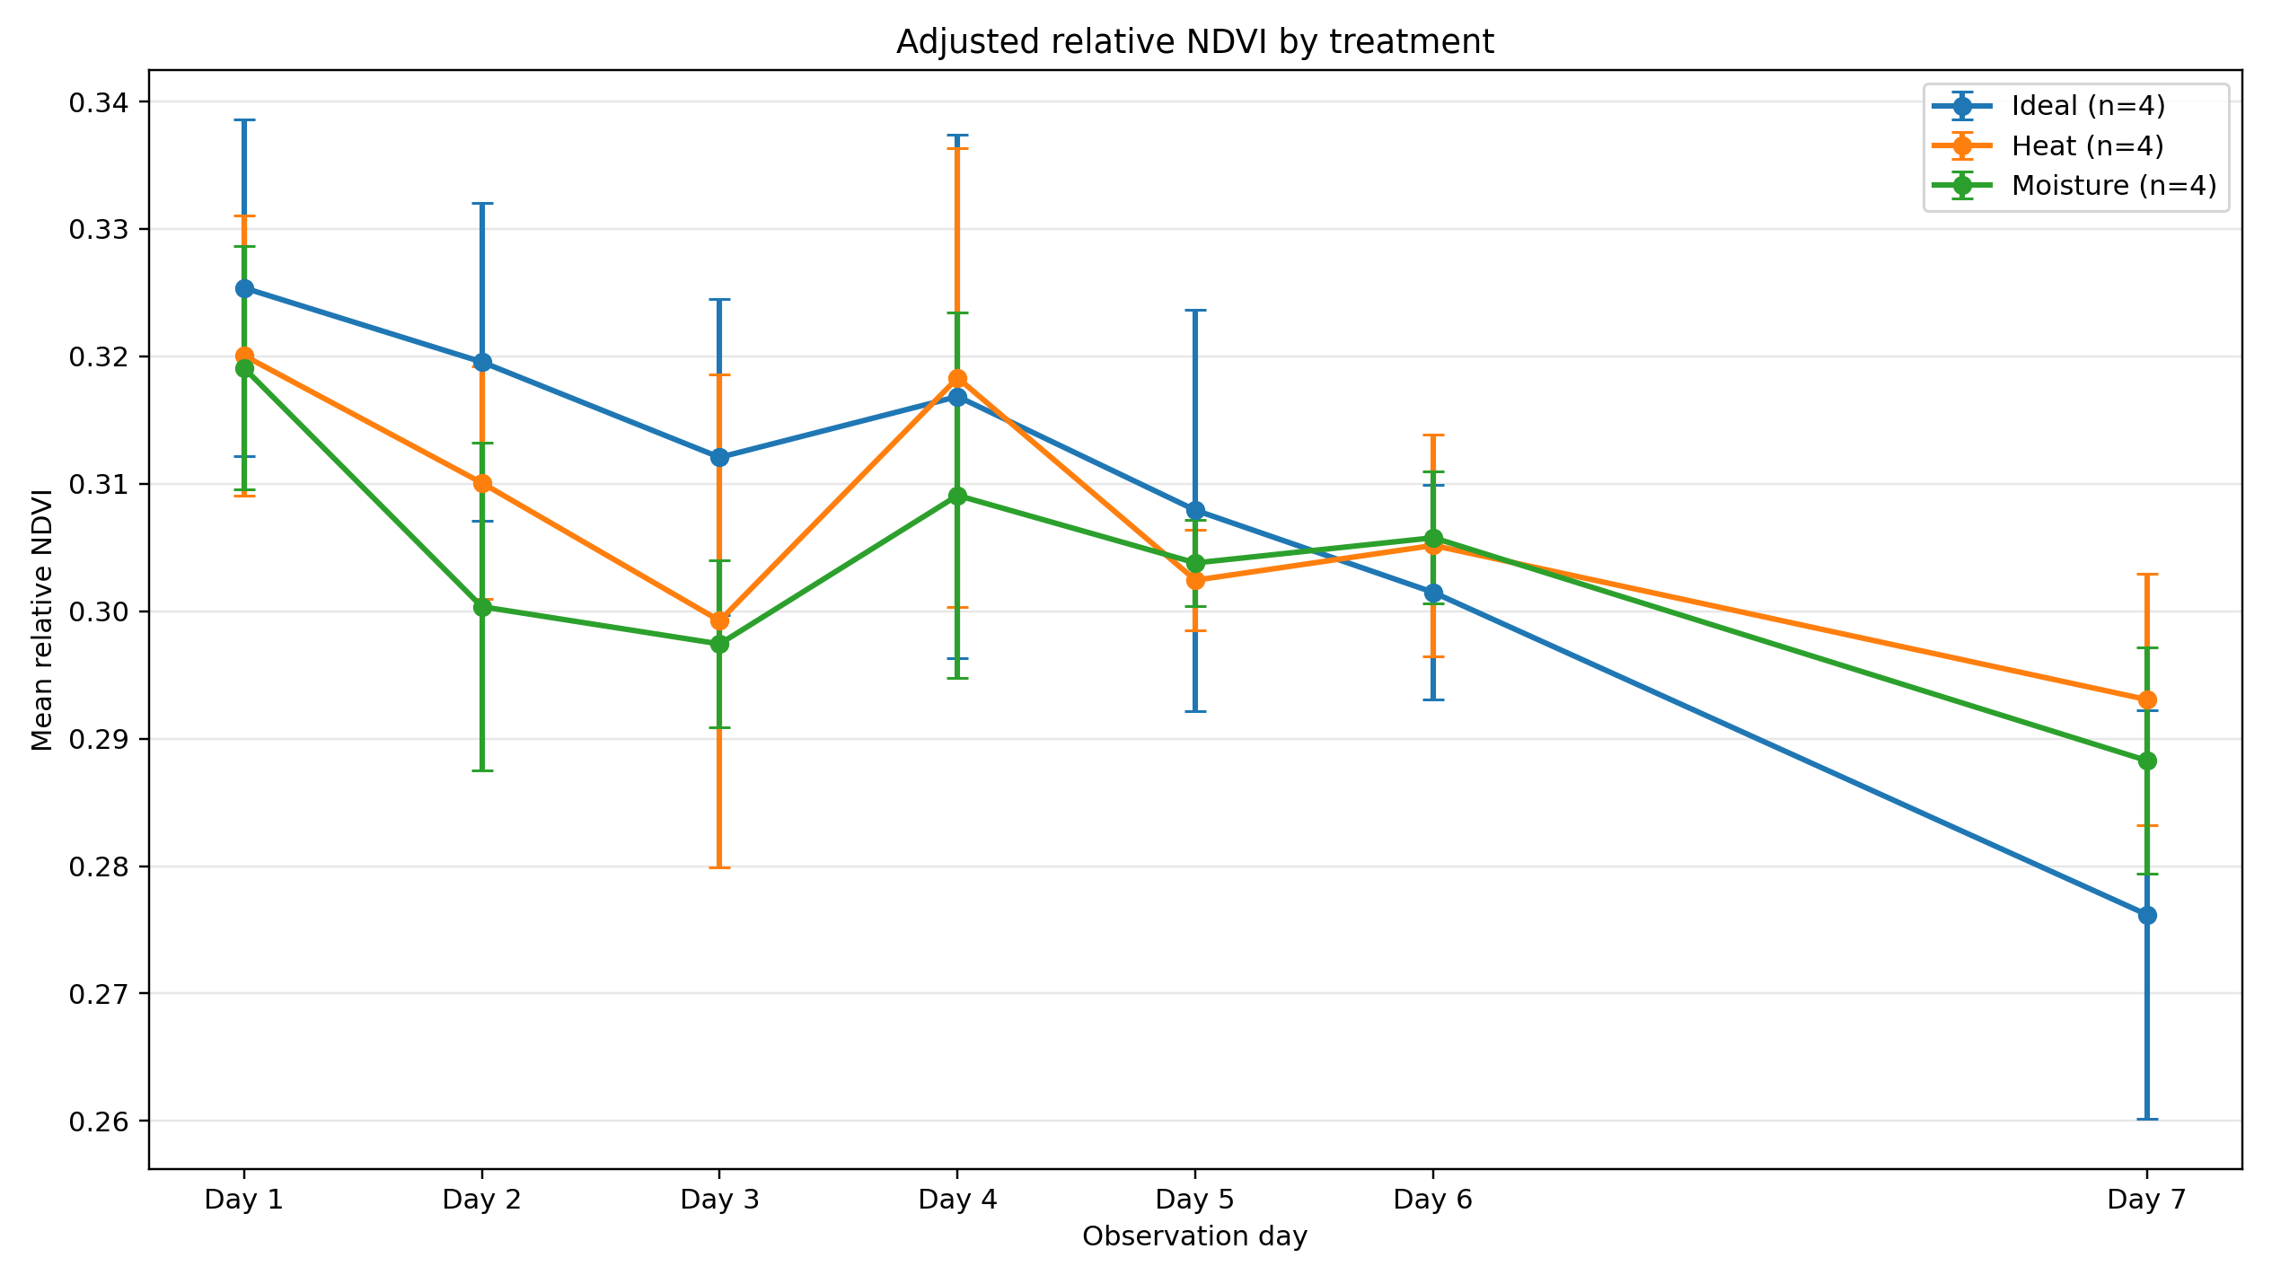
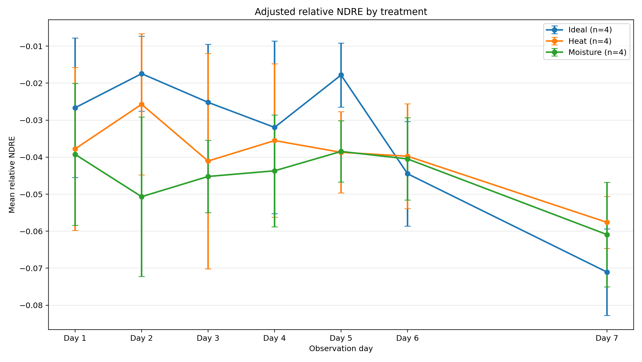

6. Ideal and Moisture: Inside vs Outside
The direct Inside-versus-Outside comparison was restricted to Ideal and Moisture trays because these treatments had fixed environmental placement. Heat trays were excluded from this direct comparison because they were moved between Inside and Outside during the experiment.
Treatment | Inside Tray Count | Outside Tray Count | Inside Trays | Outside Trays | Inside Day7 Adjusted Ndvi | Outside Day7 Adjusted Ndvi | Inside Minus Outside Day7 Ndvi | Inside Day7 Adjusted Ndre | Outside Day7 Adjusted Ndre | Inside Minus Outside Day7 Ndre | Interpretation
Ideal | 2 | 2 | Tray 9, Tray 1 | Tray 7, Tray 2 | 0.263 | 0.29 | -0.027 | -0.076 | -0.066 | -0.01 | Outside trays had higher adjusted final NDVI.
Moisture | 2 | 2 | Tray 5, Tray 12 | Tray 10, Tray 3 | 0.289 | 0.287 | 0.002 | -0.055 | -0.067 | 0.012 | Inside trays had higher adjusted final NDVI.
For Ideal, the Inside-minus-Outside adjusted Day 7 NDVI difference was -0.027 and the NDRE difference was -0.010. Outside trays had higher adjusted final NDVI.
For Moisture, the Inside-minus-Outside adjusted Day 7 NDVI difference was 0.002 and the NDRE difference was 0.012. Inside trays had higher adjusted final NDVI.
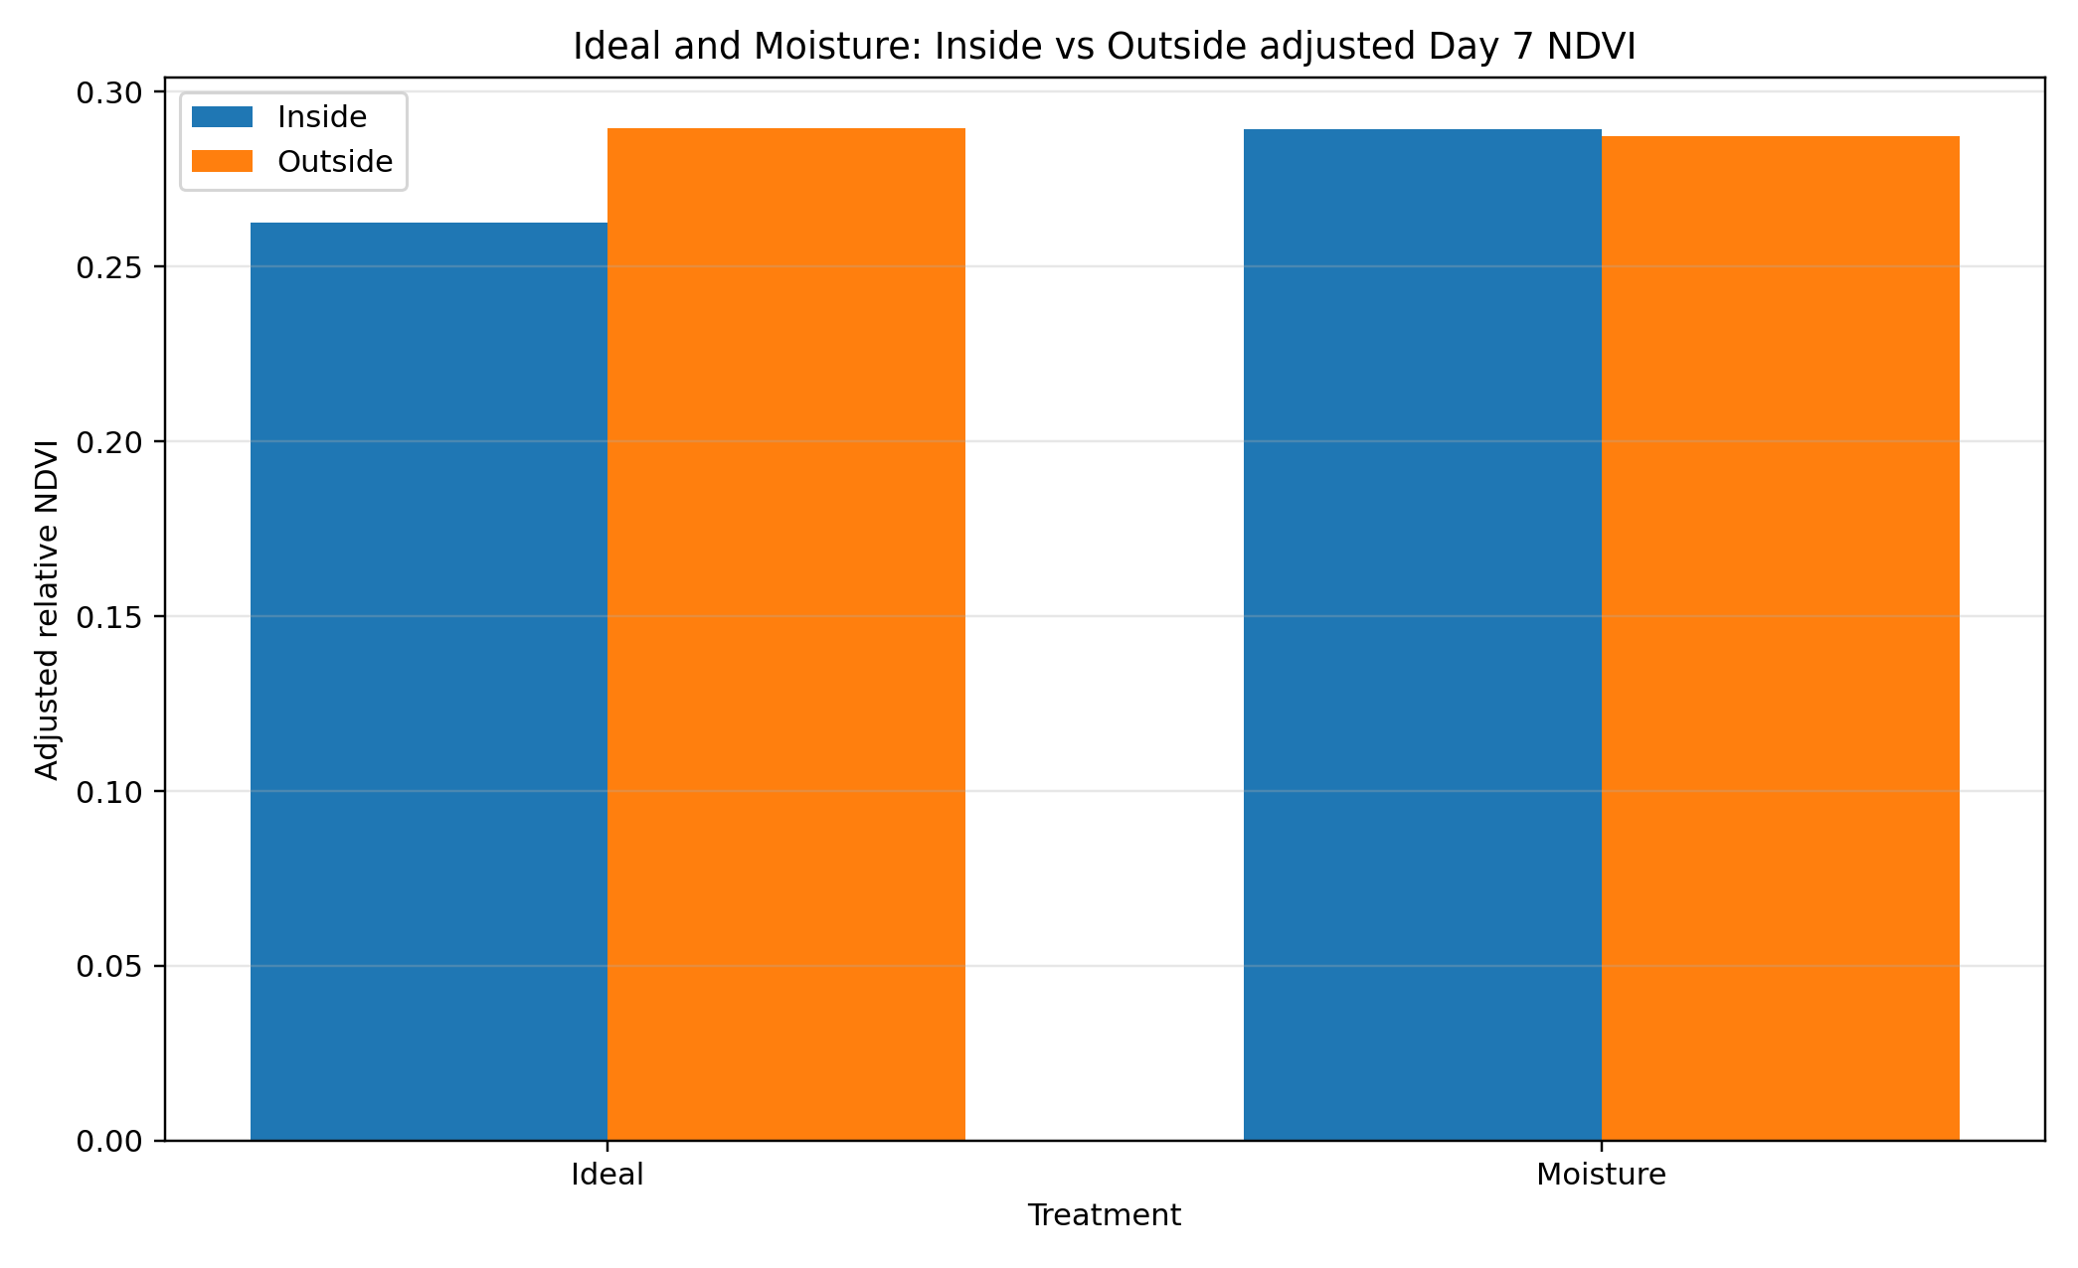
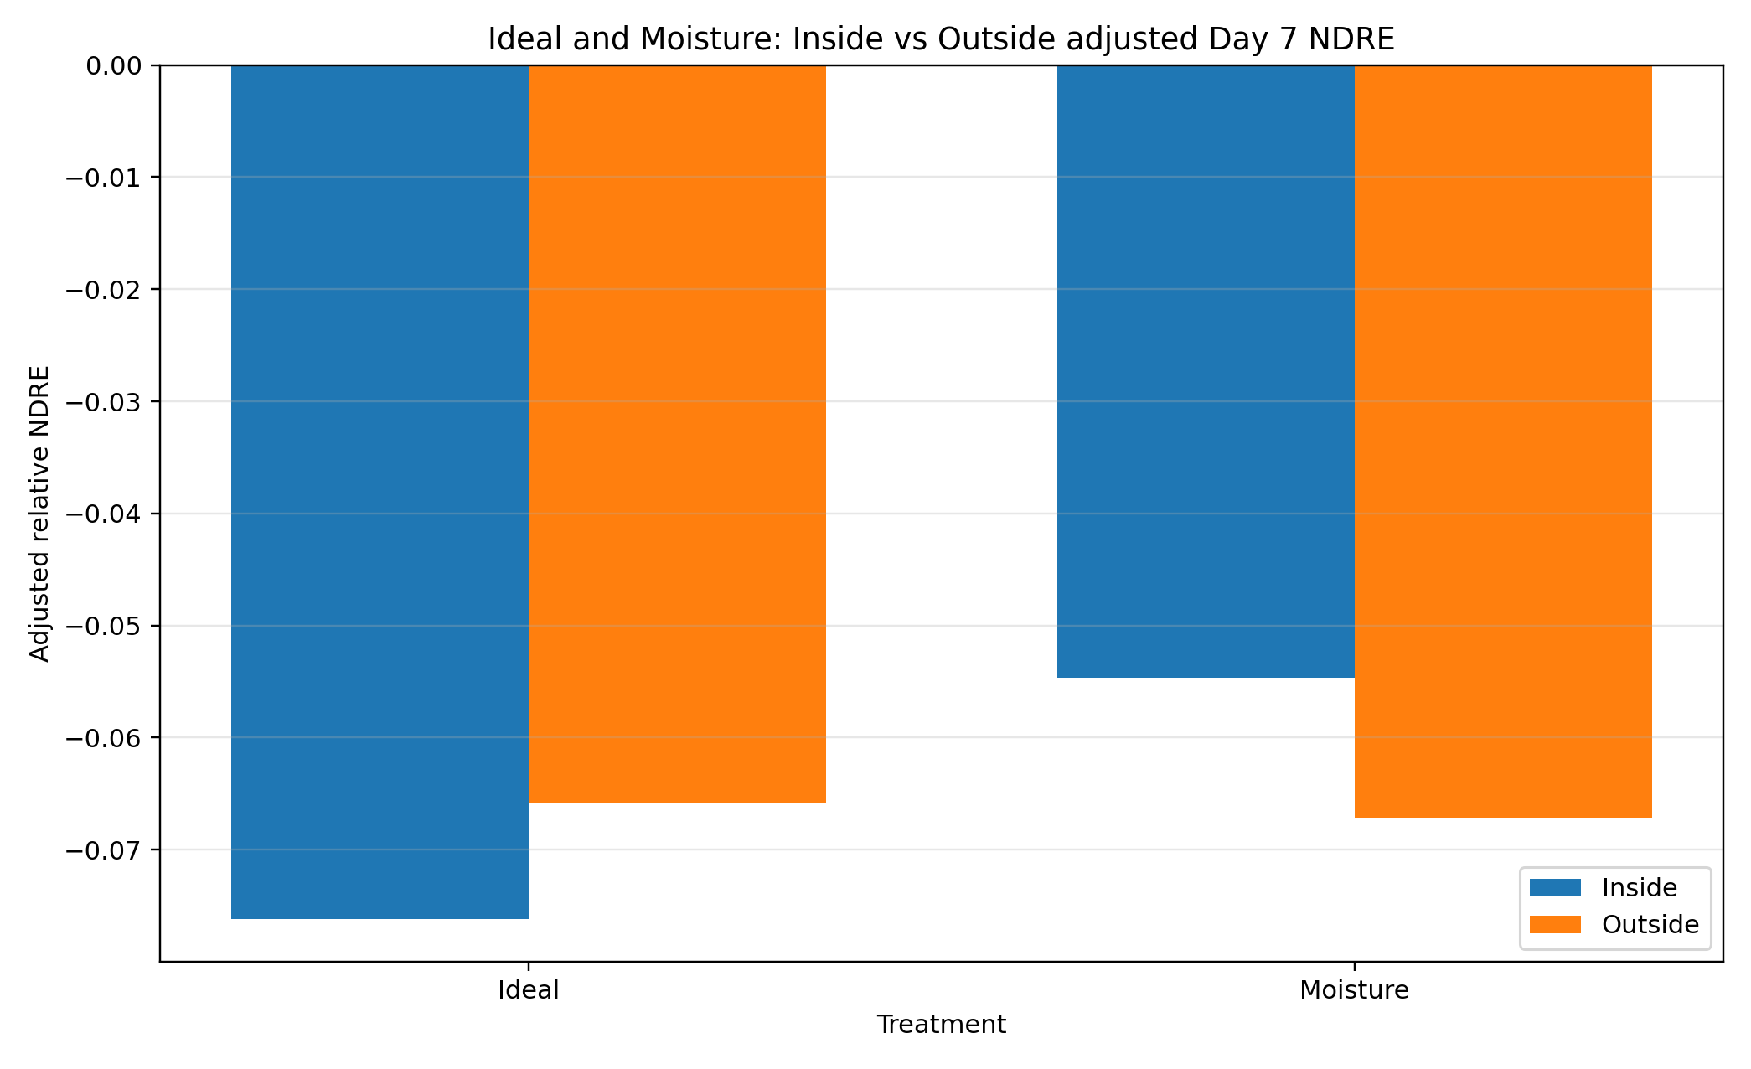

7. Heat-treatment phase response
Heat trays were Inside during the baseline period, moved Outside on Day 3, remained Outside through Days 4 and 5, and were returned Inside on Day 6. The heat-phase chart shows the adjusted relative NDVI response over this movement schedule, separated by microbial treatment.
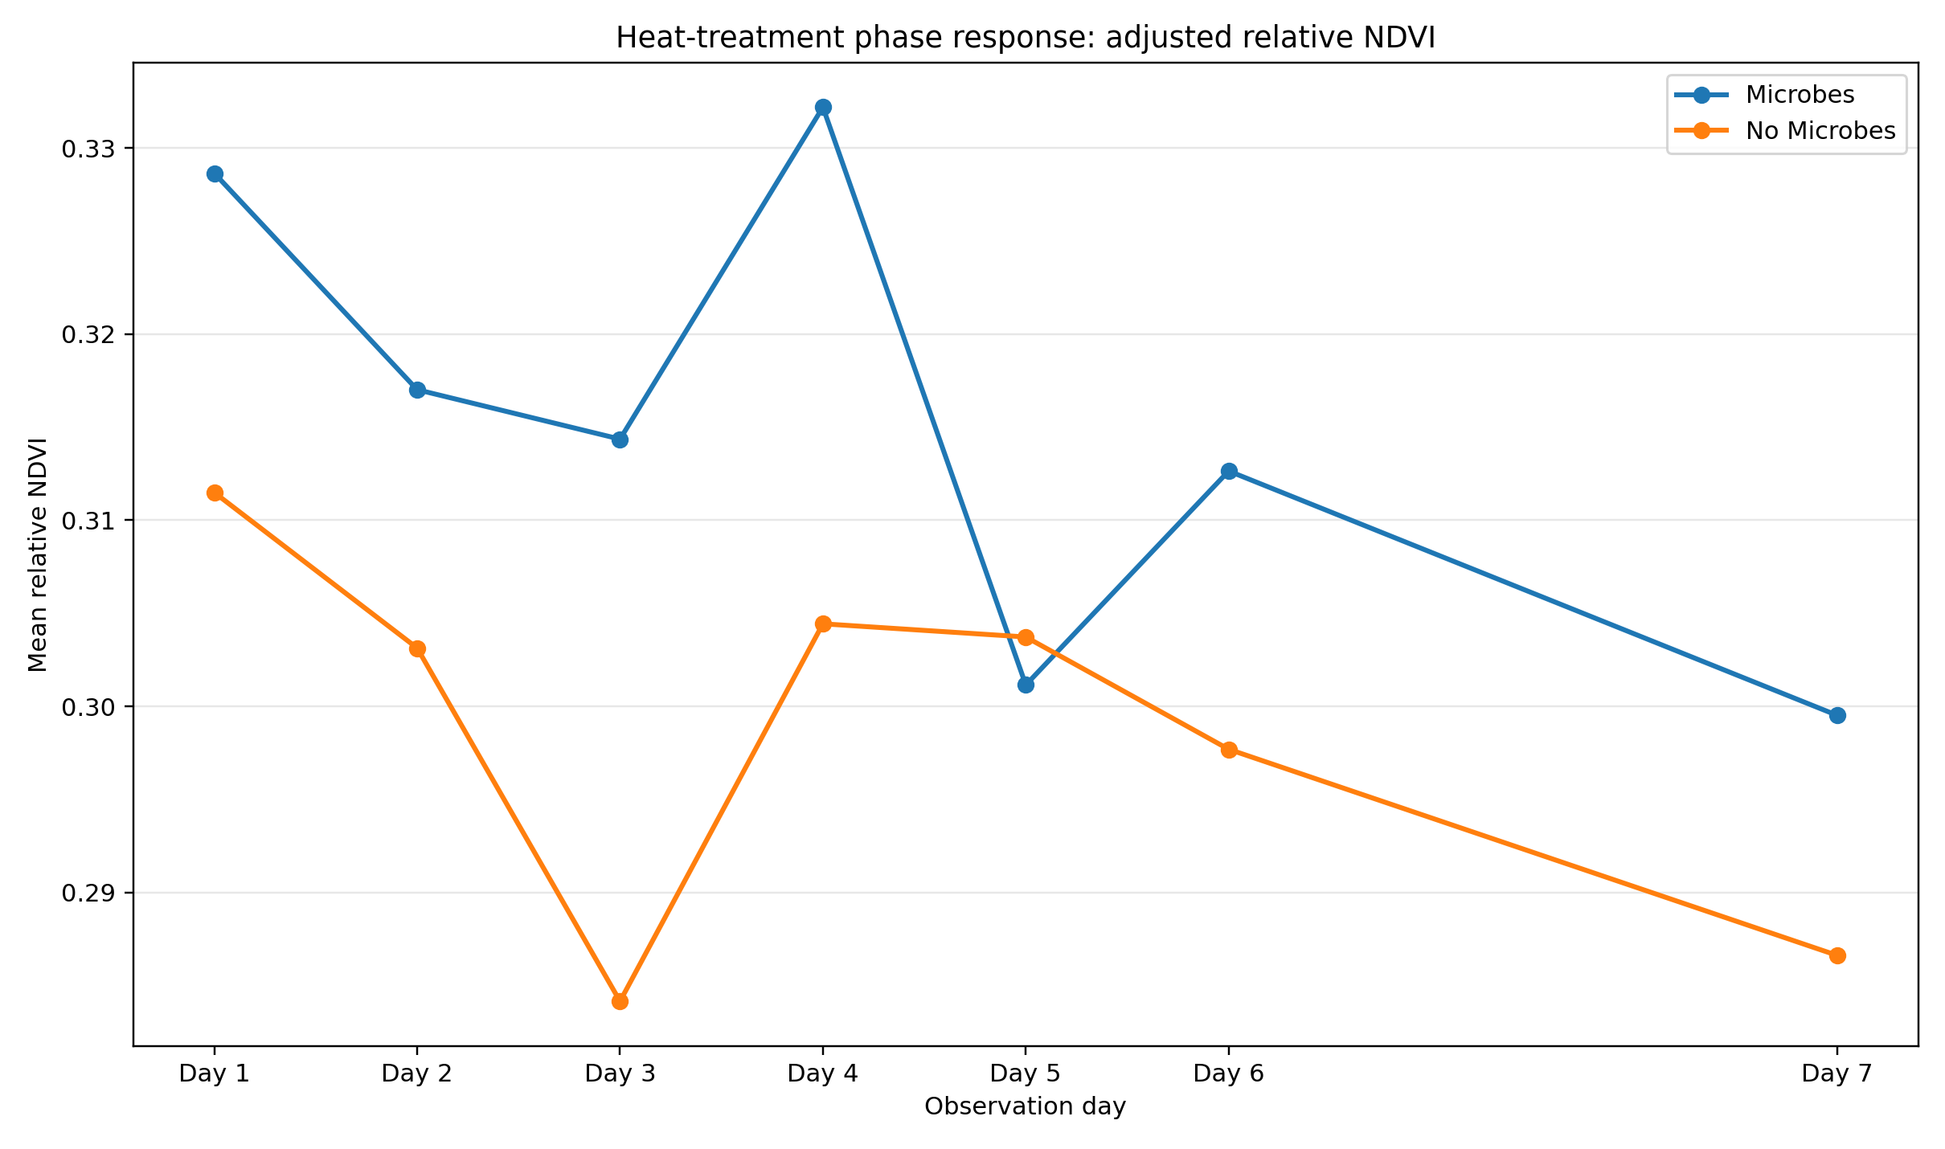

8. Moisture-treatment response
Moisture trays were watered on Day 0, Day 3 and Day 6. The remaining observation days represent drying intervals. The moisture chart compares the adjusted relative NDVI response of fixed Inside and fixed Outside moisture trays.
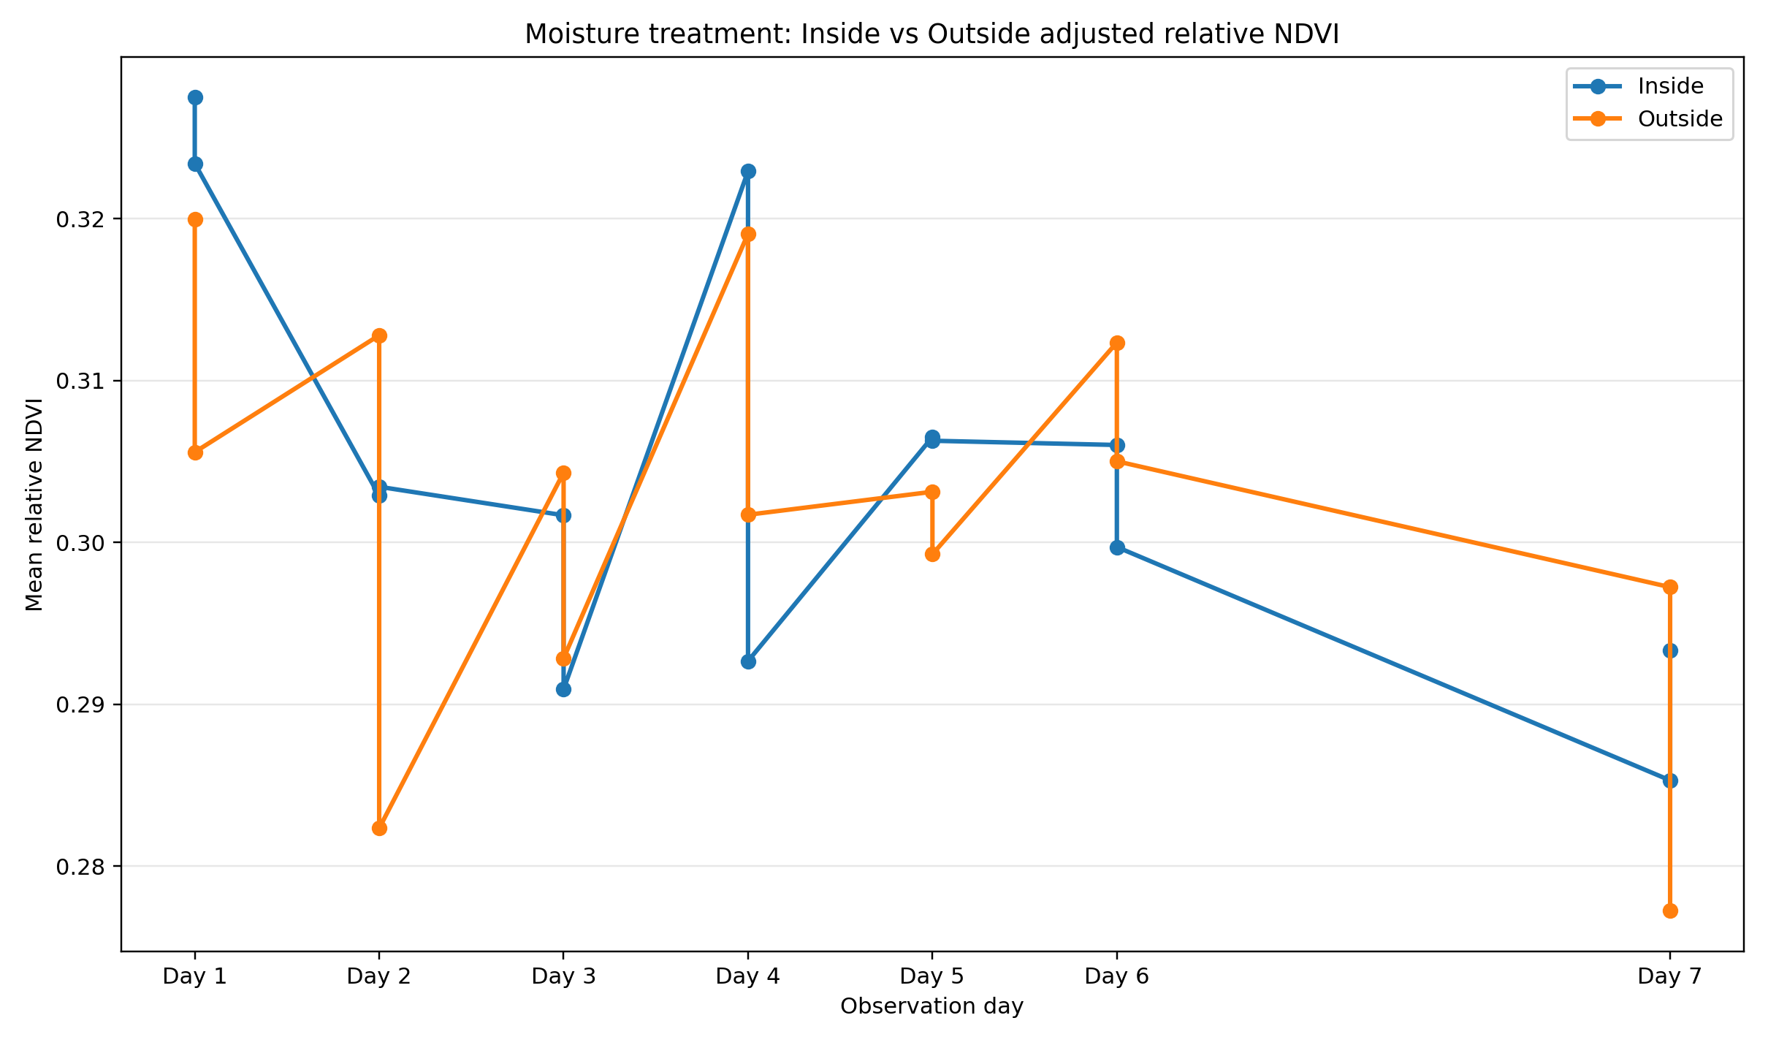

9. Description of generated CSV files
ms_cell_indices_with_day7_adjustment.csv: Full cell-level multispectral table. It preserves observed NDVI/NDRE values and adds separate adjusted Day 7 values, imputation flags, slope estimates and the source of each bug-eaten-cell flag.
ms_tray_daily_metrics.csv: Tray-by-day summary containing observed and adjusted mean NDVI/NDRE, valid-cell totals, treatment metadata and Day 7 adjusted-cell counts.
ms_tray_growth_metrics.csv: One row per tray containing Day 1, Day 6 and Day 7 indices, observed and adjusted growth rates, index area-under-curve values, adjustment differences and the descriptive multispectral ranking.
ms_group_daily_metrics.csv: Daily mean and standard-deviation results for microbial, treatment and environment-based groups. These values are used to create the trend charts.
ms_group_growth_metrics.csv: Final group-level growth table for Microbes, treatments, Microbe × Treatment, Treatment × Environment and Microbe × Environment comparisons.
inside_outside_comparison_ideal_moisture.csv: Dedicated fixed-environment comparison for Ideal and Moisture trays, including NDVI, NDRE and growth-rate differences.
heat_phase_response.csv: Heat-tray NDVI/NDRE results organised by Inside baseline, Outside exposure and Inside recovery phases.
moisture_phase_response.csv: Moisture-tray NDVI/NDRE results organised by watering events, drying intervals, environment and microbial status.
possible_day7_bug_eaten_ms_cells.csv: Filtered list of Day 7 cell records that received separate adjusted multispectral estimates.

10. Description of the Excel workbook
The file ms_treatment_comparison_report.xlsx combines the main CSV outputs into one workbook. Its sheets are Tray Growth Metrics, Tray Daily Metrics, Group Daily Metrics, Group Growth Metrics, Inside Outside Compare, Heat Phase Response, Moisture Phase Response, Day7 Adjusted Cells and Read Me.

11. Description of generated charts
01_microbes_adjusted_ndvi_trend.png: Adjusted relative NDVI trend for Microbes and No Microbes.
02_microbes_adjusted_ndre_trend.png: Adjusted relative NDRE trend for Microbes and No Microbes.
03_treatment_adjusted_ndvi_trend.png: Adjusted relative NDVI trend for Ideal, Heat and Moisture.
04_treatment_adjusted_ndre_trend.png: Adjusted relative NDRE trend for Ideal, Heat and Moisture.
05_day7_observed_vs_adjusted_ndvi_by_tray.png: Observed and adjusted final NDVI for every tray.
06_day7_observed_vs_adjusted_ndre_by_tray.png: Observed and adjusted final NDRE for every tray.
07_adjusted_ms_tray_ranking.png: Descriptive tray ranking based on adjusted NDVI/NDRE outcomes.
08_inside_outside_adjusted_ndvi_ideal_moisture.png: Inside and Outside adjusted Day 7 NDVI for Ideal and Moisture.
09_inside_outside_adjusted_ndre_ideal_moisture.png: Inside and Outside adjusted Day 7 NDRE for Ideal and Moisture.
10_heat_phase_adjusted_ndvi.png: Heat-treatment NDVI response across movement phases.
11_moisture_environment_adjusted_ndvi.png: Inside and Outside moisture-treatment NDVI response.
12_day7_imputed_cells_by_tray.png: Number of Day 7 cells receiving adjusted MS estimates by tray.

12. Interpretation limitations
The NDVI and NDRE values are relative image-derived indices. They may be affected by band calibration, exposure, soil moisture, shadows, band registration, polygon placement and the proportion of soil within each cell zone.
The Day 7 adjusted results are an analytical scenario based on the assumption that previously visible seedlings disappeared because of bug damage. The observed Day 7 values must remain the primary record of what was visible in the final images.
The overall multispectral score is a descriptive normalised ranking. It is useful for comparison and visual reporting but does not constitute a formal biological or statistical test.

